August 22, 2024

Morning Session by Aditya Kansana

Leave: medical certificate for sick leave

Application: Name, PRN no, Reason for leave, Duration

For labs, take permission from lab coordinator

faculty-kharghar@cdac.in  
CC: [adityakansana@cdac.in](mailto:adityakansana@cdac.in)

Github:

CDAC Repository

Modules

Daily Notes

Assignments

Notes

--------------------------------------------------------------------------------------------------------------------------------------

Logic Building Session by Vipul Tembulwar

Only one public class should be added in a java file.

Double, float and long are not allowed in switch statements.

Switch statement can have only default statement

Cannot write any instructions in switch without case

Loops in java:

1. For loop

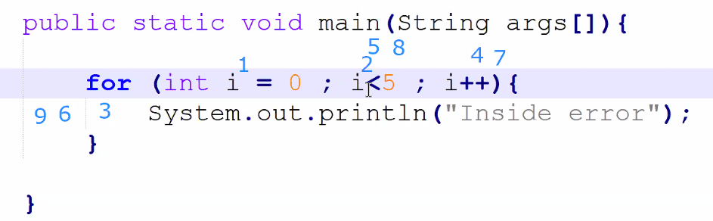

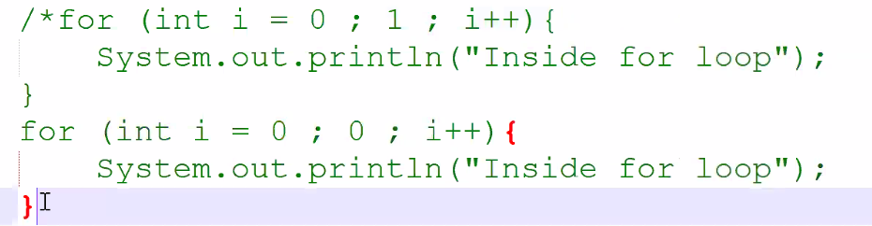

Would throw error, a boolean output should be there in condition block

Variations:

1. int a =10, b=11;

for(int i=0, j=1 ; i<5 ; i++,j++) { };

for(int i=0, j=1 ; i<5, j<5 ; i++,j++) { }; is not allowed as condition only takes a expression with Boolean output

for( ; i<5, j<5 ; i++,j++) {}; Not initialized error

1. for(;;) { } infinite loop
2. prints “init” for 1 time and “inside the loop” for 5 times

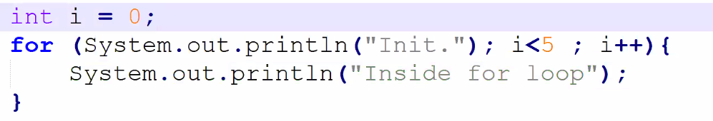

1. for(int i=0; i<5;i++);

{

System.out.println(“Hello”);

}

For loop would get terminated instantly and the block would get run separately

Pattern Questions

While loop

Difference in for loop and while loop

For loop is for defined finite repeatations

And if you don’t know the amoout of repeations required, then while loop is used

We cannot directly feed false condition to while loop

while(false){

system.out.println(“Hi”);

} would throw an error

boolean b = false;

while(b){

system.out.println(“Hi”);

} would not throw an error

do while loop

do{

statements;

}while(condition);

Do while loop firstly runs the statements inside the block and then checks for the condition

Continue Statement: To skip a iteration

Break Statement: To get out of the loop

Operators in java:

1. arithmetic + , - , / , \* , %
2. logical &&, ||, !
3. relational <, >, <=, >=, ==, !=
4. assignment =, +=, -=, \*=, /=, %=
5. bitwise &, |, ^, <<, >>
6. unary +, -, ++, --

post: First use the value and then increment (a++)

pre: First increment then use the value (b++)

1. ternary

--------------------------------------------------------------------------------------------------------------------------------------

Labs: Scope Accessibility of variables

--------------------------------------------------------------------------------------------------------------------------------------

Session by kiran ma’am in evening

Link for hackerrank challenge: <https://www.hackerrank.com/aug24-hackerrank-learning-challenge>

